positive instance percentage is 0.6271951831409934

negative instance percentage is 0.37280481685900657

Accuracy is 83.59257400903161

Precision is 90.02601908065915

Recall is 83.04

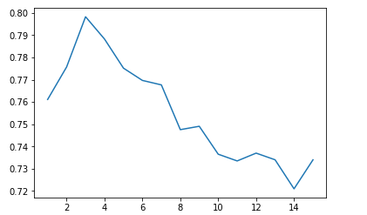

The values of y: [0.7611130653266331, 0.7756934673366834, 0.7982437185929648, 0.7882336683417085, 0.7751733668341709, 0.7696582914572864, 0.7676532663316584, 0.7475577889447236, 0.749072864321608, 0.736535175879397, 0.7335150753768844, 0.7370226130653267, 0.7340301507537689, 0.7209974874371858, 0.7340175879396986]